ORgSys

(Organization Recognition System)

Use Case Specification

Submitted to:

Asst. Prof. Ma. Rowena C. Solamo

Faculty Member

Department of Computer Science

College of Engineering

University of the Philippines, Diliman

Submitted by:

GRANADA, Patrick James B.

MERCADO, Emir R.

YAP, Sharmaine A.

In partial fulfillment of academic requirements

Revision Control

*History Revision:*

| Revision Date | Person Responsible | Version  Number | Modification |
| --- | --- | --- | --- |
| 09/13/2013 | Patrick Granada  Emir Mercado | 1.0 | Initial Document |
| 09/25/2013 | Emir Mercado | 2.0 | Revised whole document |
| 10/04/2013 | Emir Mercado | 3.0 | Revised whole document |
| 10/15/2013 | Emir Mercado  Patrick Granada  Sharmaine Yap | 4.0 | Added Use Case 5.0 specifications  Renamed Scenario 2 of Use Case 3.0 |
| 10/17/2013 | Emir Mercado | 4.1 | Removed Scenario 4 of Use Case 3.0 |

*Use-Case Name*: 1.0 Manage Organizations

*Description:* When an organization submits their documents for renewal, their respective unit head's task is to manage their submission and account in the system. Once the org's documents are approved, their submission will be uploaded online for further approval.

*Preconditions:* There must already be a requirements checklist released by the Associate Dean for Student Affairs before the organizations can submit their documents and the unit heads receive them.

*Flow of Events:*

| Scenario Name | Description |
| --- | --- |
| Scenario 1  Create org account | The unit head creates an account for the organization which means that the organization has an intent to be recognized by the college and the documents that they initially submitted are approved. |
| Scenario 2  Delete current documents | If the organization wants to update their resubmission with new files, the unit head deletes the documents currently stored in the online storage. |
| Scenario 3  Delete documents | The online storage delete the files that the unit head wants to delete. |
| Scenario 4  Upload documents | This happens when the unit head approves the documents submitted by the organization. The unit head then uploads the documents through the online storage system to have them checked by the Associate Dean for Student Affairs and the Review Committee. |
| Scenario 5  Store documents | Cloud storage keeps the files easily accessible through the internet. |

*Activity Diagram of the Flow of Events:*

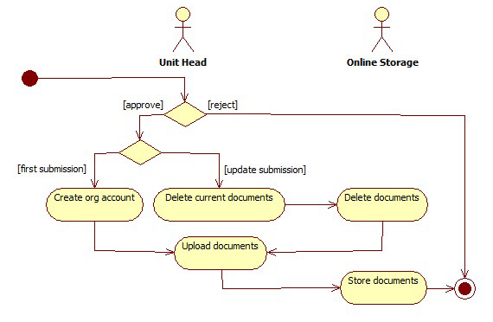

*Postcondition:* NONE

*Relationships:* The Unit Head and the Online Storage

*Special Requirements:*

NONE

*Use-Case Name*: 2.0 Manage Requirements Checklist

*Description:* The list of requirements that the organizations must submit will be created by the Associate Dean for Student Affairs. Once finalized, this will be the list to be followed by the organizations for their submissions.

*Preconditions:* NONE

*Flow of Events:*

| Scenario Name | Description |
| --- | --- |
| Scenario 1  Delete old requirements list | If this system has already been implemented year/s ago, the requirements list of the last year it was implemented will be deleted. |
| Scenario 2  Create new requirements list | A draft of the new requirements checklist will be created for the current school year. |
| Scenario 3  Finalize requirements list | The requirements checklist will be finalized by the Associate Dean for Student Affairs. Once it has been finalized, the requirements list cannot anymore be changed until the school year ends. |

*Activity Diagram of the Flow of Events:*

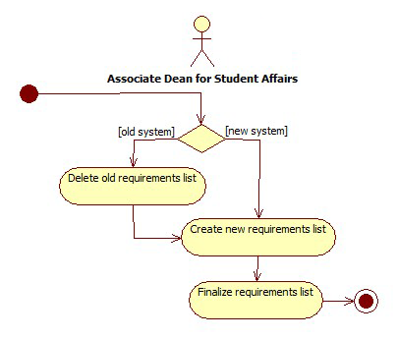

*Postcondition:* For the use-case to terminate, the requirements checklist must have been finalized and released already by the Associate Dean for Student Affairs. The checklist must exist so that the organizations know what to submit.

*Relationships* Associate Dean for Student Affairs

*Special Conditions:*

NONE

*Use-Case Name*: 3.0 Review Orgs for Recognition

*Description:* Using the requirements checklist and the criteria created, the review committee, together with the Associate Dean for Student Affairs will evaluate all the organizations.

*Preconditions:* Only the organizations who have their files uploaded in the online storage system will be reviewed by the Associate Dean for Student Affairs and the Review Committee.

*Flow of Events:*

| Scenario Name | Description |
| --- | --- |
| Scenario 1  Provide organization documents | The documents stored in the Online Storage will be made available for the Associate Dean for Student Affairs for gathering. |
| Scenario 2  Upload list of enrolled students | The Associate Dean will retrieve the list of enrolled students from the university registrar and upload it in the system. The list is used mainly to check if the students in the rosters are currently enrolled or not. |
| Scenario 3  Validate org members | Using data from the University Registrar, it will be determined if all the members of the organization listed on their roster are currently enrolled or not. The organizations' status will partly depend on the result of this validation. |
| Scenario 4  Evaluate submitted documents | The other documents submitted by the organizations, as to be specified by the requirements checklist, will be checked by the review committee and provide the proper evaluation of each set of documents. |
| Scenario 5  Recommend Approval | The Associate Dean will sign the appropriate documents signifying that he has recommended approval of these orgs to the dean. It is sign that all documents submitted by the orgs are valid and conform to the requirements given during the start of the renewal process. |

*Activity Diagram of the Flow of Events:*

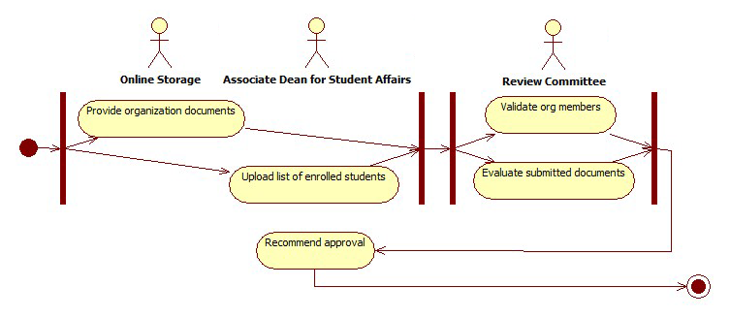

*Postcondition:* For the use-case to terminate, the review committee and the associate dean must be able to generate a status for each organization who had documents stored in the online storage.

*Relationships:* Online Storage, Review Committee, Associate Dean for Student Affairs

*Special Requirements:*

NONE

*Use-Case Name*: 4.0 View Recognition Status

*Description:* The organizations, unit heads, Associate Dean, and review committee can view the recognition status of the orgs. The information they can view depends on who made the request.

*Preconditions:* The account of the organization/s to be viewed must exist so that there is a status to display.

*Flow of Events:*

| Scenario Name | Description |
| --- | --- |
| Scenario 1  View org status | The organizations are only allowed to view their own recognition status. |
| Scenario 2  View dept. org status | The unit heads are allowed to view only the status of the orgs in their own department/institute. |
| Scenario 3  View all org status | Both the Associate Dean and the Review Committee are able to view the recognition status of all organizations. |

*Activity Diagram of the Flow of Events:*

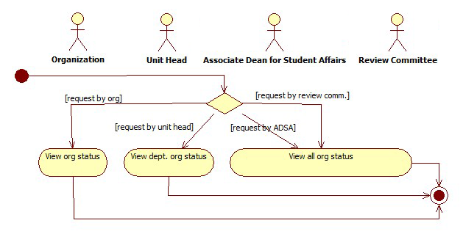

*Postcondition:* NONE

*Relationships:* Associate Dean for Student Affairs, Review Committee, Organization, Unit Head

*Special Requirements:*

NONE

*Use-Case Name*: 5.0 View Requirements Checklist

*Description:* The associate dean may be able to view the requirements checklist for reference purposes.

*Preconditions:* NONE

*Flow of Events:*

| Scenario Name | Description |
| --- | --- |
| Scenario 1  View requirements checklist | If no checklist has been made yet, no checklist will be shown. Otherwise, the latest finalized checklist of requirements will be displayed. |

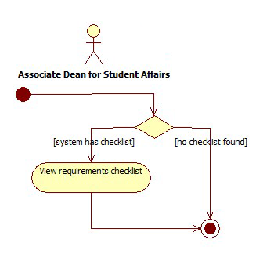

*Activity Diagram of the Flow of Events:*

*Postcondition:* NONE

*Relationships:* Associate Dean for Student Affairs

*Special Requirements:*

NONE